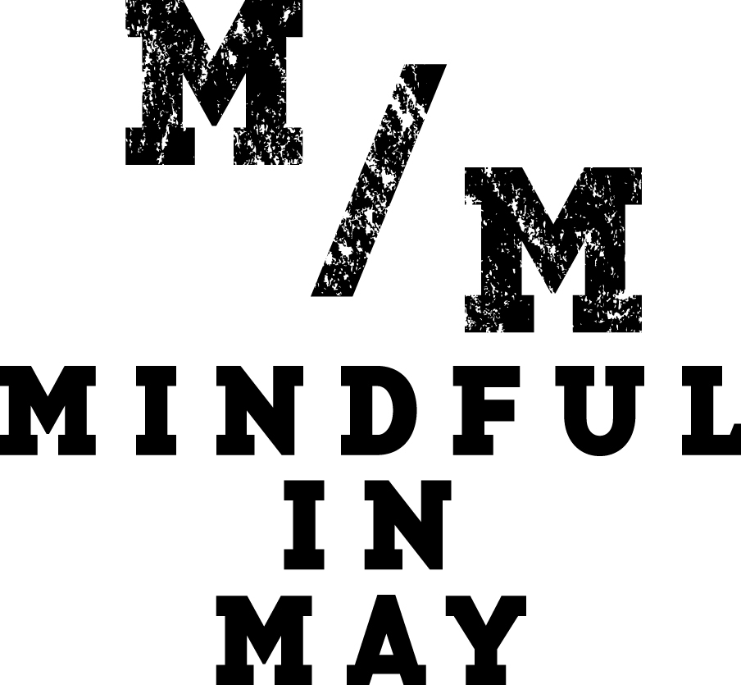

MEDIA RELEASE
Pause For A Cause With Mindful In May Global Meditation Campaign

March 2015 – In this day and age to say that our lives are busy is an understatement; with most of us racing through life at a hundred miles an hour – overworked, overwhelmed and overcommitted.

As a result of this crazy, ever-connected chaos, it can be hard to look after our own health and wellbeing, let alone find the time to help others in need.

Enter Mindful in May, a global mindfulness campaign during the month of May with two game-changing goals: to teach participants how to find calm and clarity through ten minutes of mindfulness meditation each day, and to raise money to improve access to clean drinking water in developing countries.

Everyone from individuals, businesses and schools can get involved and create their own virtual meditation team. Participants need to register at www.mindfulinmay.org from 23rd March, and then donate or get sponsored to be kept accountable to the daily challenge and make a positive difference in the world. From 1 May participants will then start the month-long meditation journey with thousands of people from around the world, and learn simple, yet transformative skills for better living. Previous participants have included actor and comedian Magda Szubanski and companies such as Google, who were the top fundraiser in 2014.

The benefits, of course, extend beyond just your own health and community. One in nine people on our planet lives without clean water and every 20 seconds a child dies. Mindful in May is also about raising money to overcome this humanitarian crisis. The program has already been incredibly successful – raising over $300,000 over the past three years for Charity Water, a not-for-profit that builds clean water wells in developing countries.

Now in its fourth year, Mindful in May is the brainchild of Elise Bialylew, doctor, and mindfulness meditation coach, who is determined to bring the transformative power of mindfulness to people around the world, while at the same time raise money to improve the lives of those in developing countries.

Elise, who has also trained in psychiatry and trained with some of the leading meditation teachers in the world, has the unique east-meets-west expertise to guide participants through this 31-day online meditation program, which involves daily inspirational emails containing weekly meditation downloads, video interviews with global experts and more.

The program offers an evidence-based approach to meditation and includes some exclusive video interviews with global experts in well-being, mindfulness and the brain, including researcher Dr. Richard Davidson (named one of the world's top 100 most influential people in 2006 Time Magazine), UCLA Clinical Professor of Psychiatry Dan Siegel and Monash University-based mindfulness researcher Dr. Craig Hassed.

“Mindful in May is not only life-changing for individuals, it’s also creating change on a global scale. The fact that we’re tackling two incredibly important issues at the same time – mental wellbeing and access to clean water – means we’re really making a difference. Every year participants say how surprised they are that only ten minutes a day of practice can be so transformative,” said Elise.

Magda Szubanski is an ambassador for Mindful in May and has seen the full affects of how meditation can help.

"I think Mindful in May is fabulous! Anything that promotes peace of mind and benefits people who are in need at the same time is a brilliant idea. I am prone to shocking anxiety, and meditation has really helped me with that. I just passed my 300th day mark since I started meditating regularly after taking part in Mindful in May. Being guided to meditate for ten minutes a day is very doable and you get real benefits," said Magda.

Mindfulness meditation has shown it can lead to structural changes in the brain, reduced stress, improved physical and mental wellbeing, reduced genetic ageing, increased happiness and enhanced immune function.

These benefits really are too good to ignore, so with health and happiness on the horizon, and clean water flowing, there’s never been a better time for us all to pause for a cause and give Mindful in May a go.
— ENDS —

How It Works:
Step 1: Register at www.mindfulinmay.org for the the ten-minute-a-day one month meditation challenge before May 1st (registration fee of $30 to provide access to the online program)
Step 2: Contribute to the cause by donating and get sponsored by friends and family to keep you accountable to the daily 10-minute meditation challenge
Step 3: Receive a meditation program delivered daily to your inbox starting May 1st
Step 4: Make a positive impact in the world and create more focus, clarity and calm for yourself

The Stats:
- One in nine people live without clean water.
- In some developing countries, children and adults travel up to six kilometres a day in search of water to drink.
- Every 20 seconds, one child dies from a disease caused by lack of access to safe drinking water. Every year four million people die from contaminated water, sanitation and hygiene-related diseases.
- It costs $35 to bring clean water to one person for life.
- The World Health Organisation predicts that by 2020, depressive illness will be the second-leading cause of global disability burden.
- The National Survey of Mental Health and Wellbeing 2007 reported that one in five (20%) Australian adults experience some form of mental illness in any year.

More information, or to organise an interview with Dr. Elise Bialylew, please contact:

Karla Brown
Under One Roof
karla@underoneroof.com.au
(03) 9224 1964 / 0414 748 030

